Lương Hoàng Lâm 20183780

Môn: Project I

Lớp 706144

1. Giải:

package com.company;  
  
import java.util.Scanner;  
  
public class bai1 {  
  
 public static void main(String[] args) {  
 System.out.println("Nhập tên :");  
 Scanner scanner = new Scanner(System.in);  
 String name = scanner.nextLine();  
  
 System.out.println("Sau khi xóa khoảng trắng thừa :");  
 System.out.println(name.replaceAll("\\s\\s+"," ").trim());  
 System.out.println("Luong Hoang Lam 20183780");  
 }  
}

Kết quả:

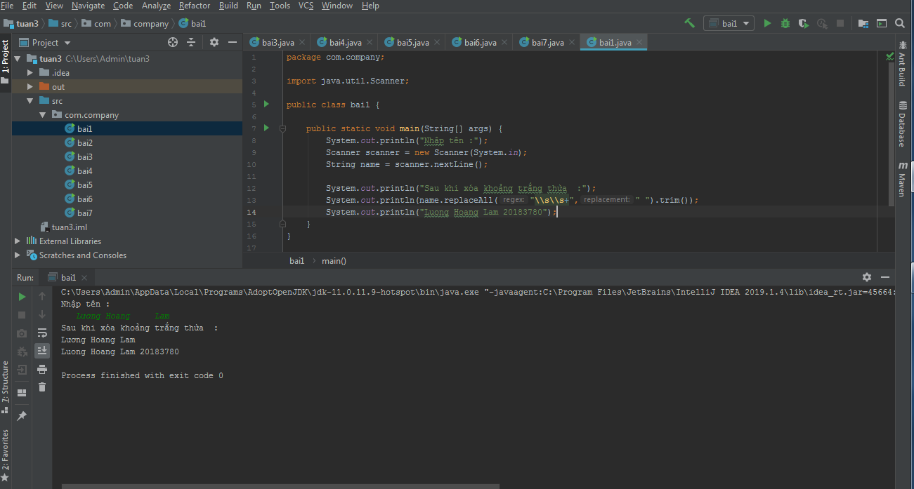

1. Giải

package com.company;  
  
import java.util.Scanner;  
  
public class bai2 {  
 public static void main(String[] args) {  
 int cnt = 0;  
 System.*out*.println("Nhap chuoi:");  
 Scanner scanner = new Scanner(System.*in*);  
 String s = scanner.nextLine();  
 for(int i =3;i<=s.length();i++){  
 if(s.substring(i-3,i).equals("abc")){  
 cnt++;  
 }  
 }  
 System.*out*.println("So lan xuat hien chuoi abc la :"+cnt);  
 System.*out*.println("Luong Hoang Lam 20183780");  
 }  
}

Kết quả :

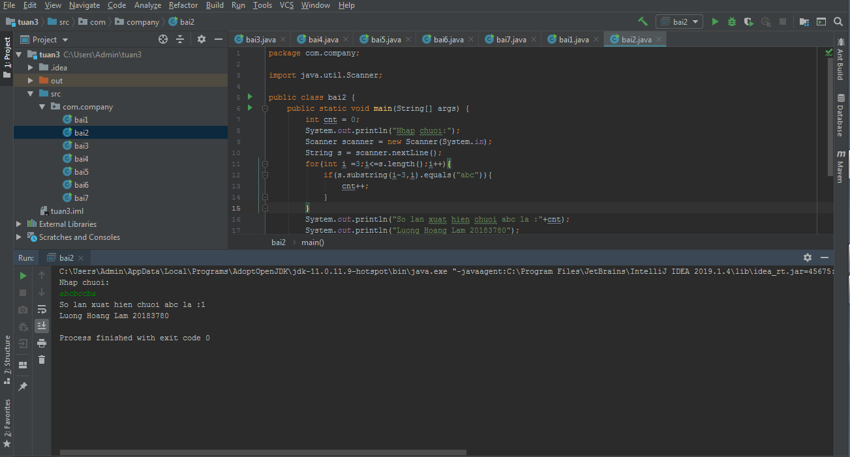

1. Giải:

package com.company;  
  
import java.util.Scanner;  
  
public class bai3 {  
 public static void main(String[] args) {  
 System.*out*.println("Nhap ten :");  
 Scanner scanner = new Scanner(System.*in*);  
 String s = scanner.nextLine();  
 String name = s.trim();  
 for (int i = name.length() - 1; i >= 0; i--) {  
 if (String.*valueOf*(name.charAt(i)).equals(" ")) {//kiem tra dau cach cuoi cung trong ten  
 String last_name = name.substring(i + 1);  
 System.*out*.println("Ten :" + last_name);  
 break;  
 }  
 }  
 System.*out*.println("Luong Hoang Lam 20183780");  
 }  
}

Kết quả :

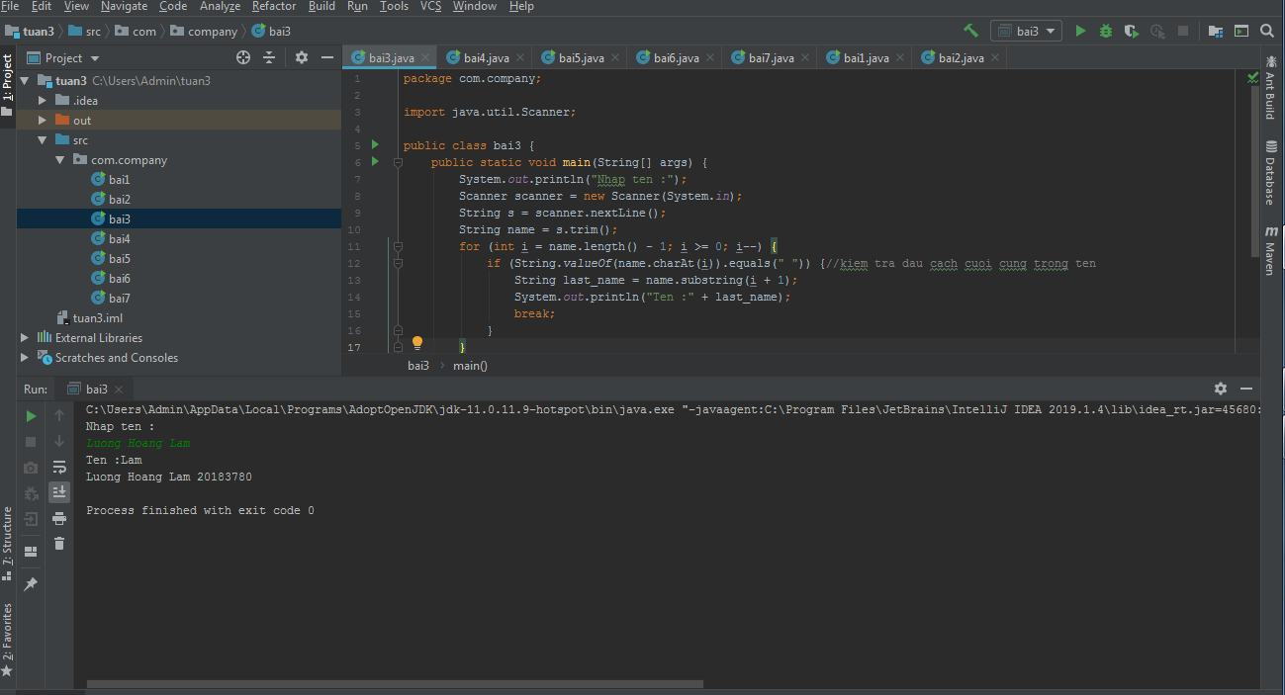

1. Giải:

package com.company;  
  
import java.util.Scanner;  
  
public class bai4 {  
 public static void main(String[] args) {  
 System.*out*.println("Nhap ten:");  
 Scanner scanner = new Scanner(System.*in*);  
 String s = scanner.nextLine();  
  
 String name = s.trim();  
 for(int i = 0;i<name.length();i++){  
 if(String.*valueOf*(name.charAt(i)).equals(" ")){  
 String first_name = name.substring(0,i);  
 System.*out*.println("Ho: " + first_name);  
 break;  
 }  
 }  
 System.*out*.println("Luong Hoang Lam 20183780");  
 }  
}

Kết quả :

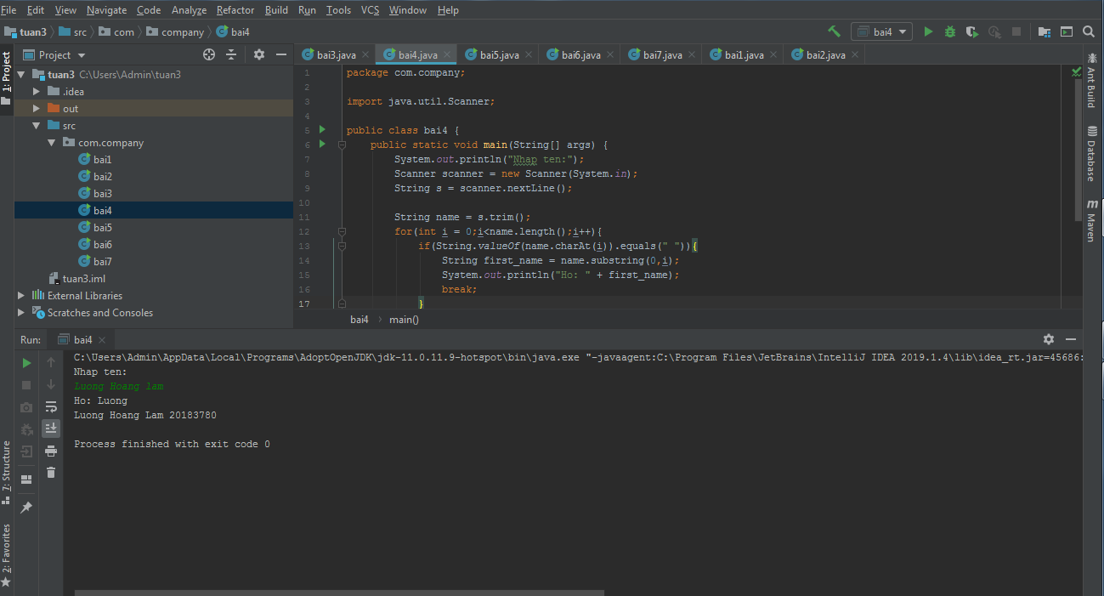

1. Giải

package com.company;  
  
import java.util.Scanner;  
  
public class bai5 {  
  
 public static void main(String[] args) {  
 System.*out*.println("Nhap so luong hoc sinh:");  
 Scanner scanner = new Scanner(System.*in*);  
 int n = Integer.*parseInt*(scanner.nextLine());  
 System.*out*.println("Nhap ten can kiem tra :");  
 String name_check = scanner.nextLine();  
 int cnt =0;//bien dem  
 for(int i = 0;i<n;i++){  
 System.*out*.println("Nhap hoc sinh thu "+(i+1)+":");  
 String s = scanner.nextLine();  
 if(*check*(s,name_check)){  
 cnt++;  
 }  
 }  
 System.*out*.println("So luong hoc sinh trung ten "+name_check+" la :"+cnt);  
 System.*out*.println("Luong Hoang Lam 20183780");  
 }  
  
 private static boolean check(String s,String name_check) {  
 String full_name = s.trim();  
 int n = s.length();  
 for(int i = n-1;i>=0;i--){  
 if(String.*valueOf*(full_name.charAt(i)).equals(" ")){  
 String last_name = full_name.substring(i+1);  
 if(last_name.equalsIgnoreCase(name_check)){  
 return true;  
 }  
 }  
 }  
 return false;  
 }  
}

Kết quả :

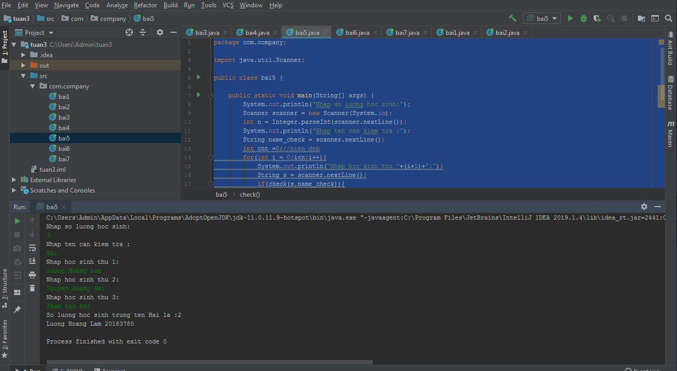

1. Giải

package com.company;  
  
import java.util.Scanner;  
  
public class bai6 {  
 public static void main(String[] args) {  
 System.*out*.println("Nhap so luong hoc sinh:");  
 Scanner scanner = new Scanner(System.*in*);  
 int n = Integer.*parseInt*(scanner.nextLine());  
 System.*out*.println("Nhap ten dem can kiem tra :");  
 String name_check = scanner.nextLine();  
 int cnt = 0;//bien dem  
 for(int i =0;i<n;i++){  
 System.*out*.println("Nhap hoc sinh thu "+(i+1)+":");  
 String s = scanner.nextLine();  
 if(*check*(s,name_check)){  
 cnt++;  
 }  
 }  
 System.*out*.println("So luong hoc sinh co ten dem "+'"' +name_check+'"' + " la : " +cnt);  
 System.*out*.println("Luong Hoang Lam 20183780 ");  
 }  
  
 private static boolean check(String s, String name_check) {  
 String name = s.trim().replaceAll("\\s\\s+"," ");  
 String[] tmp = name.split(" ");  
 if(tmp.length < 3){  
 System.*out*.println("Khong co ten lot ");  
 }  
 if(name_check.equalsIgnoreCase(tmp[1])){  
 return true;  
 }  
 return false;  
 }  
}

Kết quả :

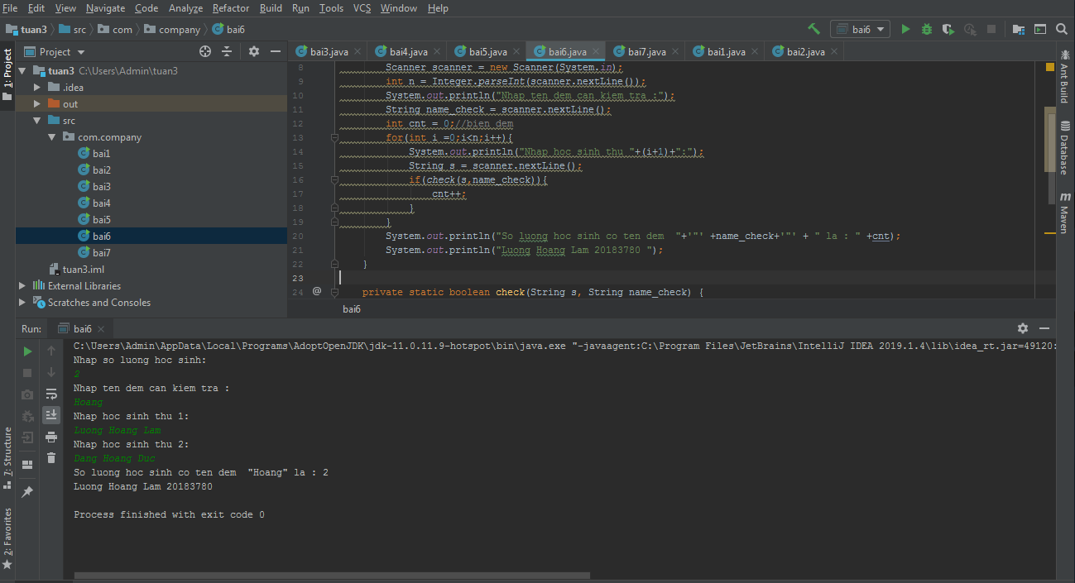

1. Giải:

package com.company;  
  
import java.util.Scanner;  
  
public class bai7 {  
 public static void main(String[] args) {  
 System.*out*.println("Nhap so luong hoc sinh:");  
 Scanner scanner = new Scanner(System.*in*);  
 int n = Integer.*parseInt*(scanner.nextLine());  
 System.*out*.println("Nhap chu cai can kiem tra :");  
 String name_check = String.*valueOf*(scanner.nextLine().charAt(0));  
 int cnt =0;//bien dem  
 for(int i = 0;i<n;i++){  
 System.*out*.println("Nhap hoc sinh thu "+(i+1)+":");  
 String s = scanner.nextLine();  
 if(*check*(s,name_check)){  
 cnt++;  
 }  
 }  
 System.*out*.println("So luong hoc sinh trung chu cai "+name_check+" la :"+cnt);  
 System.*out*.println("Luong Hoang Lam 20183780");  
 }  
  
 private static boolean check(String s,String name_check) {  
 String full_name = s.trim();  
 int n = s.length();  
 for(int i = n-1;i>=0;i--){  
 if(String.*valueOf*(full_name.charAt(i)).equals(" ")){  
 if(String.*valueOf*(full_name.charAt(i+1)).equalsIgnoreCase(name_check)){  
 return true;  
 }  
 }  
 }  
 return false;  
 }  
 }

Kết quả :

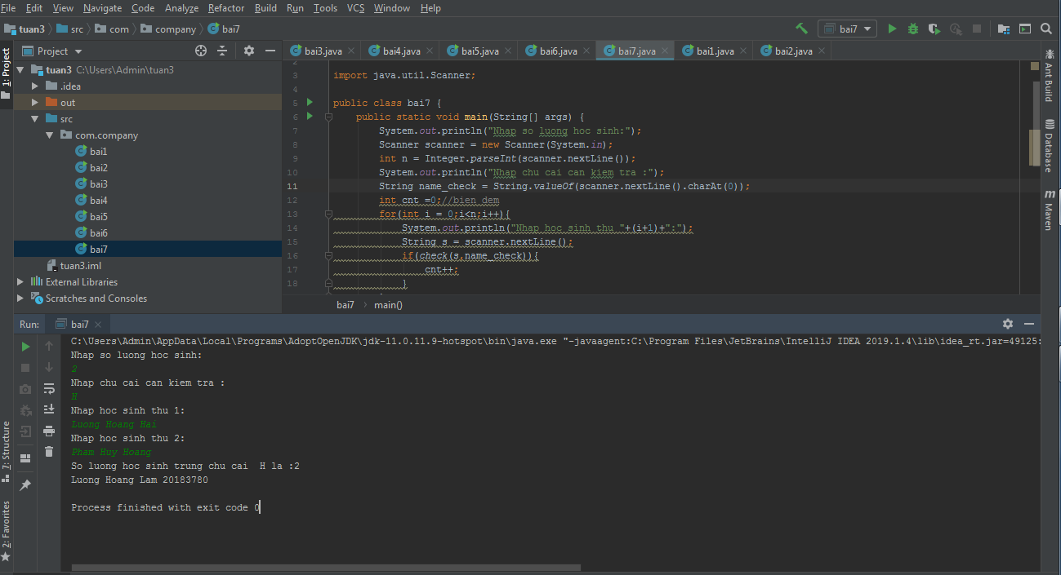

Link github: [lamgnaoh/project-I: project 1 20203 (github.com)](https://github.com/lamgnaoh/project-I)